**TOPIC 5.1 : MAXIMUM COINS COLLECTION**

**Problem Statement**

There are 3n piles of coins of varying size. You and your friends will take piles of coins as follows:

* In each step, you will choose any 3 piles of coins (not necessarily consecutive).
* Alice will pick the pile with the maximum number of coins.
* You will pick the next pile with the maximum number of coins.
* Bob will pick the last pile.  
  Repeat until there are no more piles of coins.

Given an array of integers piles where piles[i] is the number of coins in the ith pile, return the maximum number of coins that you can have.

**Example 1**

**Input:** piles = [2,4,1,2,7,8]  
**Output:** 9

**Explanation:**

* Choose triplet (2,7,8): Alice → 8, You → 7, Bob → 2
* Choose triplet (1,2,4): Alice → 4, You → 2, Bob → 1  
  Your total = 7 + 2 = **9**

**Example 2**

**Input:** piles = [2,4,5]  
**Output:** 4

**Aim**

To write a program that finds the maximum number of coins you can collect by selecting optimal triplets from the given piles of coins.

**Algorithm**

1. Start
2. Read the array of integers piles
3. Sort the array in descending order
4. Initialize result = 0
5. Iterate through the array by choosing every second element starting from index 1 (second largest in each triplet)
   * Add this element to result
6. Continue until all triplets are used
7. Return result
8. Stop

**Input and Output**

* Input: piles = [2,4,1,2,7,8] → Output: 9
* Input: piles = [2,4,5] → Output: 4  
    
  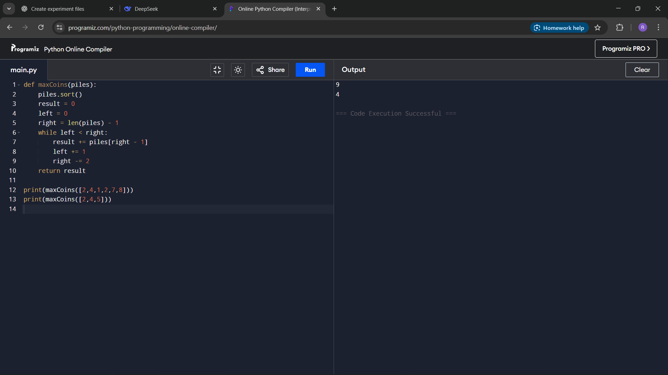

**Result**

The program successfully finds the maximum number of coins you can collect by following the rules of the game.

**Performance Analysis**

* **Time Complexity:**
  + Sorting → O(n log n)
  + Selecting coins → O(n)
  + Overall → O(n log n)
* **Space Complexity:**
  + O(1) if sorting is done in-place, otherwise O(n)